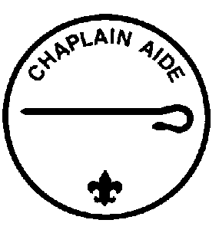
Troop 109
Leadership Position Description
CHAPLIN AIDE
GENERAL INFORMATION
Type: Appointed by the Senior Patrol Leader
Term: 6 months
Reports to: Assistant Senior Patrol Leader
Description: The Chaplin Aide works with the Troop Chaplin to meet the religious needs of Scouts in the troop. He also works to promote the religious awards program.
Comments: "Duty to God" is one of the core beliefs of Scouting. The Chaplin Aide helps everyone in the troop by preparing short religious observations for campouts and other functions. The Chaplin Aide does not always lead the observation himself and can have other troop members’ help.
QUALIFICATIONS
Age: none
Rank: none
Experience: none
Attendance: 60% over the previous 6 months
Participation: Fundraisers & Service Projects

PERFORMANCE REQUIREMENTS
Training: You must attend the troop Junior Leader Training even if you have attended in the past.
Attendance: You are expected to attend 60% of all troop meetings, Patrol Leaders' Council meetings, outings, and service projects. If your attendance is low you can be removed from office.
Effort: You are expected to give this job your best effort.
GENERAL LEADERSHIP RESPONSIBILITIES
Uniform: Set the example by wearing your uniform correctly. This means that you will wear all of the parts of the troop uniform, shirttail tucked in, with all required badges in their correct locations.
Behavior: Set the example by living the Scout Oath and Law in your everyday life. Show Scout Spirit in everything you say and do.
Attendance: Set the example by being an active Scout. Be on time for meetings and activities. You must call the Senior Patrol Leader or Scoutmaster if you are not going to be at a meeting or if you suddenly have to miss an outing. You also need to make sure that someone will assume your responsibilities.
SPECIFIC LEADERSHIP RESPONSIBILITIES
Assists with religious services at troop activities
Tells Scouts about the religious emblem program for their faith
Makes sure religious holidays are considered during troop program planning
Helps plan for religious observance in troop activities

