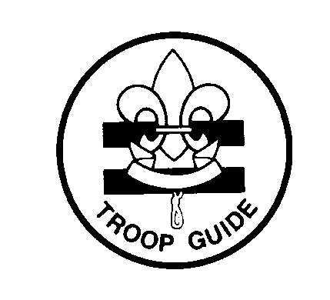
Troop 109
Leadership Position Description
TROOP GUIDE
GENERAL INFORMATION
Type: Appointed by the Scoutmaster
Term: 12 months
Reports to: Assistant Scoutmaster
Description: The Troop Guide works with new Scouts. He helps them feel comfortable and earn their First Class rank in their first year.
Comments: The first year as a Boy Scout is a critical time with new places, new people, new rules, and new activities. The Troop Guide is a friend to the new Scouts and makes first year fun and successful. This is an important position.
QUALIFICATIONS
Age: 13 or older
Rank: 1st Class or higher
Experience: none
Attendance: 90% over previous 6 months
Participation: Fundraisers & Service Projects
PERFORMANCE REQUIREMENTS
Training: You must attend the troop Junior Leader Training even if you have attended in the past.
Attendance: You are expected to attend 90% of all troop meetings, Patrol Leaders' Council meetings, outings, and service projects. If your attendance is low you can be removed from office.
Effort: You are expected to give this job your best effort.
GENERAL LEADERSHIP RESPONSIBILITIES
Uniform: Set the example by wearing your uniform correctly. This means that you will wear all of the parts of the troop uniform, shirttail tucked in, with all required badges in their correct locations.
Behavior: Set the example by living the Scout Oath and Law in your everyday life. Show Scout Spirit in everything you say and do.
Attendance: Set the example by being an active Scout. Be on time for meetings and activities. You must call the Senior Patrol Leader or Scoutmaster if you are not going to be at a meeting or if you suddenly have to miss an outing. You also need to make sure that someone will assume your responsibilities.
SPECIFIC LEADERSHIP RESPONSIBILITIES
Introduces new Scouts to troop operations
Guides new Scouts through early Scouting activities
Shields new Scouts from harassment by older Scouts
Helps new Scouts earn First Class in their first year
Teaches basic Scout skills
Attends Patrol Leaders' Council meetings
Assists with training

